**Junior Programmer:** Programming Theory

Project Brief

Overview

In this project I will implement 4 principals of OOP (Abstraction, Inheritance, Polymorphism, Encapsulation). The prototype will consist of 2 scenes: Start scene and gameplay scene. In the gameplay scene the player will be able to control 2 types of units: forklift and man. The player will be able to move them around with WSAD. The forklift unit can move pick-up skids and put them down. The man will increase the production of skid.

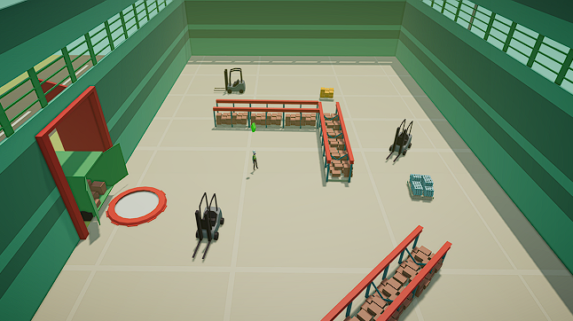

Abstraction:

* will be used in Unit Movement script;

Inheritance:

* will be used in Forklift Unit and Worker Unit scripts, they will derive from Unit Movement Script;

Encapsulation:

* will be used on production variables and scores;

Polymorphism:

* will be used in Unit Movement script, since the forklift can’t rotate while not moving and a man can, Unit Movement script will have 2 functions Rotate(), one of them will take object’s current speed to check if it is moving and rotate it accordingly.